**Basic Linux Commands**

**26: unzip**

Unzip files in Linux

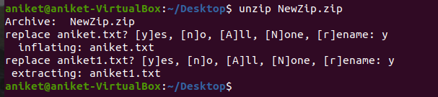

**27: mv**

It is used to rename the file.



**28: grep**

If you wish to search for a specific string within an output, the grep command comes into the picture. We can pipe (**|**) the output to the grep command and extract the required string.



29: rmdir

The [rmdir](https://www.javatpoint.com/linux-rmdir) command is used to delete a directory.



30: cat >

The [cat](https://www.javatpoint.com/linux-cat) command is a multi-purpose utility in the Linux system. It can be used to create a file, display the content of the file, copy the content of one file to another file, and more.

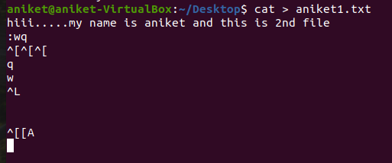

31: head

The [head](https://www.javatpoint.com/linux-head) command is used to display the content of a file. It displays the first 10 lines of a file.



32: tail

The [tail](https://www.javatpoint.com/linux-tail) command is similar to the head command. The difference between both commands is that it displays the last ten lines of the file content. It is useful for reading the error message.

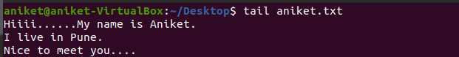



33: tac

The [tac](https://www.javatpoint.com/linux-tac) command is the reverse of cat command, as its name specified. It displays the file content in reverse order (from the last line).

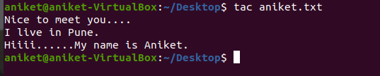

34: more

The [more](https://www.javatpoint.com/linux-more) command is quite similar to the cat command, as it is used to display the file content in the same way that the cat command does. The only difference between both commands is that, in case of larger files, more command displays screenful output at a time.

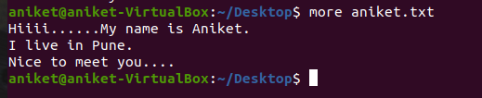

35: less

The [less](https://www.javatpoint.com/linux-less) command is similar to the more command. It also includes some extra features such as 'adjustment in width and height of the terminal.' Comparatively, the more command cuts the output in the width of the terminal.

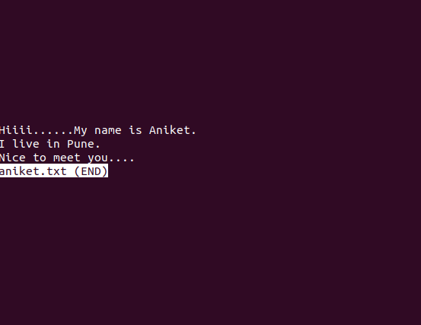

36: su

The [su](https://www.javatpoint.com/linux-su-commands) command provides administrative access to another user. In other words, it allows access of the Linux shell to another user.



37: id

The [id](https://www.javatpoint.com/linux-id-command) command is used to display the user ID (UID) and group ID (GID).



38: rename

The [rename](https://www.javatpoint.com/linux-rename) command is used to rename files. It is useful for renaming a large group of files.

39: groupadd

The [groupadd](https://www.javatpoint.com/linux-add-user-to-group) command is used to create a user group.

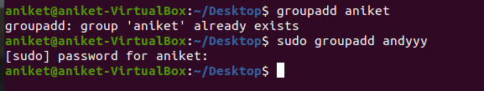

40: passwd

The [passwd](https://www.javatpoint.com/linux-user-password) command is used to create and change the password for a user.

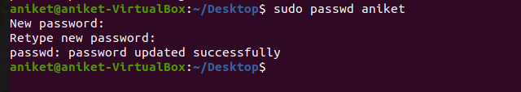

41: cut

The [cut](https://www.javatpoint.com/linux-cut) command is used to select a specific column of a file. The '-d' option is used as a delimiter, and it can be a space (' '), a slash (/), a hyphen (-), or anything else. And, the '-f' option is used to specify a column number.

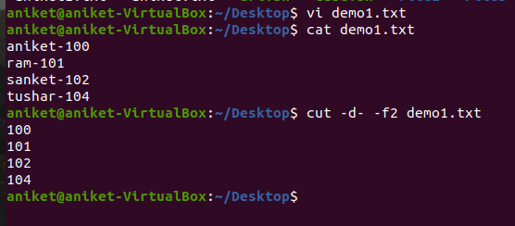

42: comm

The ['comm'](https://www.javatpoint.com/linux-comm) command is used to compare two files or streams. By default, it displays three columns, first displays non-matching items of the first file, second indicates the non-matching item of the second file, and the third column displays the matching items of both files.

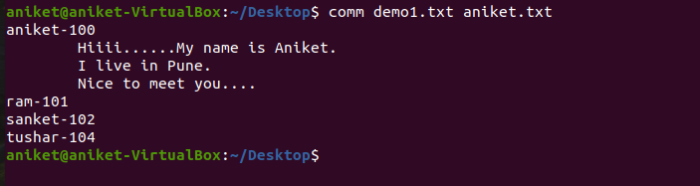

43: sed

The [sed](https://www.javatpoint.com/linux-sed) command is also known as **stream editor**. It is used to edit files using a regular expression. It does not permanently edit files; instead, the edited content remains only on display. It does not affect the actual file.

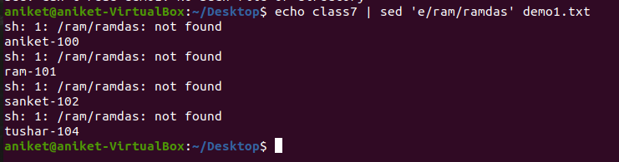

44: tee

The [tee](https://www.javatpoint.com/linux-tee) command is quite similar to the cat command. The only difference between both filters is that it puts standard input on standard output and also write them into a file.

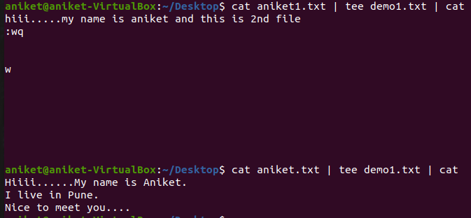

45: tr

The [tr](https://www.javatpoint.com/linux-tr) command is used to translate the file content like from lower case to upper case.

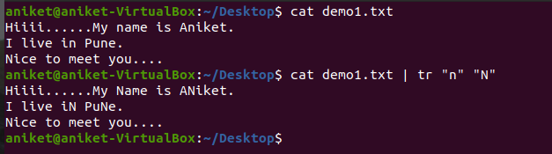

46: uniq

The [uniq](https://www.javatpoint.com/linux-uniq) command is used to form a sorted list in which every word will occur only once.

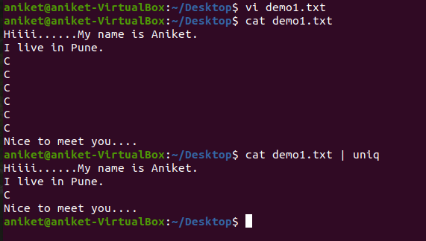

47: wc

The [wc](https://www.javatpoint.com/linux-wc) command is used to count the lines, words, and characters in a file.

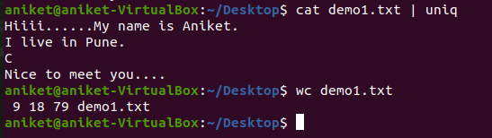

48: od

The [od](https://www.javatpoint.com/linux-od) command is used to display the content of a file in different s, such as hexadecimal, octal, and ASCII characters.

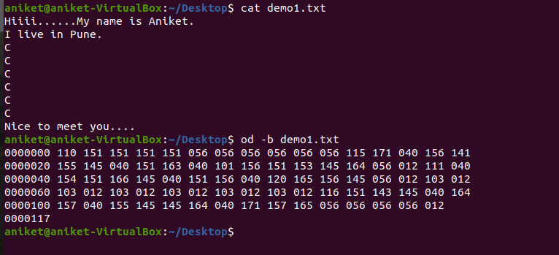

49: sort

The [sort](https://www.javatpoint.com/linux-sort) command is used to sort files in alphabetical order.

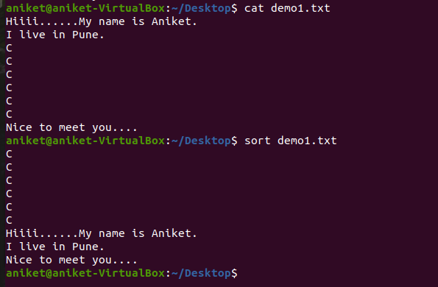

50: gzip

The [gzip](https://www.javatpoint.com/linux-gzip) command is used to truncate the file size. It is a compressing tool. It replaces the original file by the compressed file having '.gz' extension.

